**Detailed Project Understanding &  
Proposal for Library Management Software**

**Prepared By: Quickly platform**

**Introduction**

Thank you for your interest in partnering with Quickly platforms for your Library management Software system. With well over 100,000 firms offering website development App development services, we know how challenging it can be to find the right agency for development of your Library Management software.

At Quickly platforms, we hold one goal above all others: 100% client satisfaction. Our in house team of web designers, App Designers, copywriters, graphic designers, and developers uphold the highest standards for project planning and execution, and we're dedicated to building the perfect website for your company ontime and onbudget.

We've built websites and application for several brands around the world with great success, and are quite excited to get to work on yours.

In this proposal, you'll find examples of our past work along with what we feel is the optimal solution for your project needs, along with the associated delivery timeline, costs, and project terms. Once you've reviewed this proposal thoroughly, simply electronically sign it at the bottom to indicate your approval.  
  
Please contact me directly if you have any queries or concerns.  
  
  
Thanks again for the opportunity to earn your business!

**Project Title: (Library Management software)**

**Objective:** The objective of the Library Management Software project is to develop a comprehensive and userfriendly platform that facilitates the efficient management of **library operations**, including **user registration**, **catalog management**, **borrowing, returning**, and reservations.  
  
It aims to enhance **user experience by offering secure authentication**, intuitive navigation, and seamless access to library resources, Additionally, the software will provide administrators with tools to **manage inventory**, **generate reports**, and **ensure data protection**, while offering integration with external systems for a modern, responsive, and scalable library solution.

### ****Scope:**** The scope of the Library Management Software project includes developing features for user registration, catalog management, borrowing/returning, reservations, and reporting. It will provide administrators with tools to manage inventory, users, and library settings, with secure access and data protection. Optional features include a mobile app and social features like book reviews and recommendations.

### Project Scope Includes As per General Document

**Core Features Includes**

* **User Management:** Secure user registration, authentication, and rolebased access (admin, librarian, member).
* **Catalog Management:** Add, edit, search, and browse books with detailed information (title, author, genre.).
* **Borrowing and Returning:** Automated checkout, return process, due date management, and renewals.
* **Reservation System:** Reserve books and receive notifications when they become available.
* **Reporting and Analytics**: Generate reports on user activity, inventory, and financial transactions.

**Key Features**

* **Notifications and Alerts:** Automated reminders for due dates, reservations, and overdue books.
* **Inventory Management:** Track available, borrowed, and reserved books in realtime.
* **Profile Management:** Users can update their profile, view borrowing history, and manage reservations.
* **Integration with External Systems:** Payment gateways for fines and integration with external book databases for automatic information retrieval.
* **Security and Compliance:** Data protection, access control based on user roles, and regular backups with a recovery plan.

### Scope of work

**Scope of Work for Library Management Software**

**1. User Management**

* Develop a secure user registration and authentication system.
* Implement rolebased access for admins, librarians, and members.
* Provide profile management features, including borrowing history and personal information updates.

**2. Catalog Management**

* Design functionality to add, edit, and manage book entries with detailed information.
* Enable users to search and browse the catalog by title, author, genre, or ISBN.
* Implement inventory tracking to monitor available, borrowed, and reserved books.

**3. Borrowing and Returning**

* Build an automated checkout and return system for managing book loans.
* Implement due date assignment and automated notifications for overdue books.
* Include book renewal functionality if no reservations exist.

**4. Reservation System**

* Develop a reservation system for books that are currently checked out.
* Notify users when reserved books become available.

**5. Reporting and Analytics**

* Create reports for user activity (e.g., borrowing history, overdue items).
* Generate inventory and financial reports, tracking book usage and collected fines.

**6. Administration and Settings**

* Provide admins with tools to manage users, books, and library settings (e.g., fine rates, borrowing limits).
* Offer options to configure notification preferences and manage categories.

**7. Integrations**

* Integrate payment gateways for online fine payments.
* Connect with external book databases for automatic book detail retrieval.

**8. Security and Compliance**

* Ensure the system meets data protection regulations, with secure access controls and regular backups.

**9. User Interface**

Design a responsive and intuitive user interface for easy navigation across devices.

**10. Optional Features**

* Develop a mobile app for easier access.
* Add social features like book reviews, ratings, and recommendations.

**We are proposing a web based platform for administrative tasks, allowing users to manage various aspects of the library management software from a desktop or laptop  
And For user we can build web solution + mobie Apps.**

**End to End Key Features of Library Management Software**

**1. User Registration and Management**

* User account creation with secure authentication and rolebased access (admin, librarian, member).
* Profile management for updating details and viewing borrowing history.

**2. Catalog Management**

* Add, edit, and categorize books with detailed metadata (title, author, ISBN, genre).
* Search and browse the catalog with filters for categories, availability, and genres.
* Realtime inventory tracking for available, borrowed, and reserved books.

**3. Borrowing and Returning**

* Automated checkout process capturing user and book information.
* Realtime update of book status on return, with options for renewals.
* Due date assignment and notifications for overdue items or upcoming returns.

**4. Reservation System**

* Allow users to reserve books that are currently checked out.
* Notify users when reserved books become available for pickup.

**5. Notifications and Alerts**

* Automated email or app notifications for book availability, due dates, renewals, and overdue items.

**6. Reporting and Analytics**

* Generate user activity reports (borrowing history, overdue items).
* Detailed inventory reports on book usage, availability, and stock levels.
* Financial reporting for overdue fees, fines, and other transactions.

**7. Payment and Fee Management**

* Integration with payment gateways for fine collection.
* Automatic calculation of overdue fees with secure online payment options.

**8. Security and Data Compliance**

* Secure data storage with encryption for user data and borrowing information.
* Rolebased access control and compliance with data protection regulations.

**9. Administrative Tools**

* Admin dashboard for managing users, books, borrowing limits, fine rates, and notification settings.
* Options to edit book details, manage categories, and configure systemwide settings.

**10. Integrations**

* Integration with external book databases ( ISBN databases) for automatic retrieval of book information.
* Payment gateway integration for fine payments and fee management.

**11. Mobile Accessibility**

* Responsive design for accessibility on desktop, tablet, and mobile devices.
* Optional mobile app for easy access to library services on the go.

**12. Backup and Recovery**

* Automated data backup and a clear recovery process in case of system failures or data loss.

**13. Optional Social Features**

* Usergenerated reviews, ratings, and book recommendations to engage the community.

**User Flow of Library Management system (User side)**

**1. User Registration**

* Action: User visits the registration page.
* Input: Enters required details (name, email, contact info, password).
* Outcome: User receives a confirmation email with an activation link.

**2. User Login**

* Action: User clicks on the login button.
* Input: Enters email and password.
* Outcome: Successful login redirects to the user dashboard; unsuccessful login displays an error message.

**3. User Dashboard**

Overview: Displays borrowing history, reserved books, and notifications.

**Options:**

* View Profile: Access and update personal information.
* Browse Catalog: Navigate to the book catalog.

**4. Catalog Browsing/Search**

* Action: User navigates to the catalog.
* Input: Uses filters (author, genre, ISBN) or search bar to find books.
* Outcome: Displays a list of matching books with options to view details.

**5. Book Details**

* Action: User clicks on a book title to view detailed information.
* Overview: Displays book details (author, publication date, availability).

**Options:**

* Check Out: If available, the user can initiate the borrowing process.
* Reserve: If checked out, the user can reserve the book.

**6. Borrowing Process**

* Action: User clicks on "Check Out."
* Outcome: Confirmation of borrowing, displaying due date and option to view borrowing history.

**7. Returning a Book**

* Action: User navigates to "My Borrowed Books."
* Input: Selects a book to return.
* Outcome: Confirmation of return, updating inventory, and notifying the user of the return status.

**8. Renewing a Book**

* Action: User selects a borrowed book with the option to renew.
* Outcome: If no reservations exist, the due date is extended.

**9. Reservation Process**

* Action: User reserves a book that is currently checked out.
* Outcome: Confirmation of reservation and notification settings for when the book becomes available.

**10. Notifications**

* Overview: User receives email/app notifications for:

Overdue items

* Reserved book availability
* Upcoming due dates

**11. Reporting and Analytics (Admin Flow)**

* Action: Admin logs in to the admin dashboard.

**Options:**

* View user activity reports, inventory reports, and financial reports.
* Manage users and books.

**12. Payment of Fines**

* Action: User navigates to the payment section.
* Input: Selects fines to pay and enters payment details.
* Outcome: Confirmation of payment and updating of the user's financial status.

**13. Logout**

* Action: User clicks on the logout button.
* Outcome: User is logged out and redirected to the home page.

**Flow Summary**

The user flow begins with **registration and login**, progresses through catalog browsing and book **management (borrowing, returning, renewing, and reserving),** and ends with notifications and payment processing.  
  
Admin users have their own **flow for managing users, books, and reporting**, while ensuring a seamless experience for all types of users.

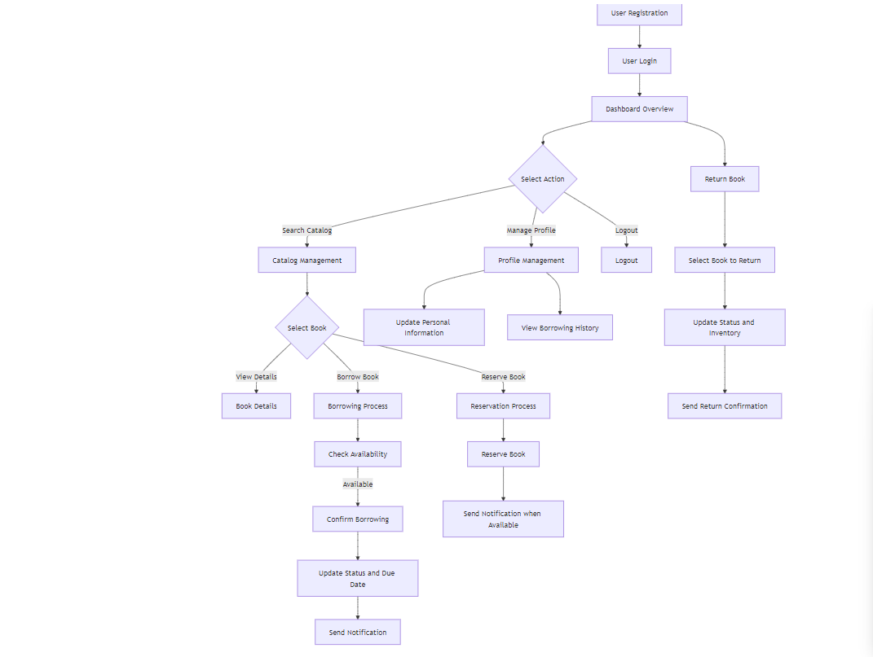

**Link:** [**http://surl.li/zozbht**](http://surl.li/zozbht) **check this for flow understanding**

**Admin users Flow of library management software**

**Admin User Flow for Library Management Software**

**1. Admin Login**

* Action: Admin navigates to the login page.
* Input: Enters admin credentials (email and password).
* Outcome: Successful login redirects to the admin dashboard; unsuccessful login displays an error message.

**2. Admin Dashboard**

* Overview: Displays key metrics such as total users, active loans, reserved books, and overdue items.

**Options:**

* Manage Users
* Manage Books
* View Reports
* Settings

**3. Manage Users**

* Action: Admin selects "Manage Users" from the dashboard.

**Options:**

* View All Users: Displays a list of registered users with their details.

**Add New User:**

* Input: Enters new user details (name, email, role).
* Outcome: User account created and a confirmation email sent.

**Edit User:**

* Action: Admin selects a user to edit.
* Input: Updates user information or role.
* Outcome: Changes saved, and the user is notified if necessary.

**Delete User:**

* Action: Admin selects a user to delete.
* Outcome: User account is removed, and confirmation is provided.

**4. Manage Books**

* Action: Admin selects "Manage Books" from the dashboard.

**Options:**

* View All Books: Displays a list of all books in the catalog.

**Add New Book:**

* Input: Enters book details (title, author, ISBN, genre, publication date).
* Outcome: Book added to the catalog and inventory updated.

**Edit Book:**

* Action: Admin selects a book to edit.
* Input: Updates book information.
* Outcome: Changes saved, and inventory reflects updates.

**Delete Book:**

* Action: Admin selects a book to delete.
* Outcome: Book removed from the catalog.

**5. View Reports**

* Action: Admin selects "View Reports" from the dashboard.

**Options:**

* User Activity Reports: View borrowing history, overdue items, and active memberships.
* Inventory Reports: Insights on the most borrowed books, lowstock items, and overall library usage.
* Financial Reports: Track fees collected from overdue books and other transactions.

**6. Settings Management**

* Action: Admin selects "Settings" from the dashboard.

**Options:**

* Configure Library Settings: Set borrowing limits, fine rates, and notification preferences.
* Manage Categories: Create or edit categories for book classification.

**7. Notifications Management**

* Action: Admin manages notification settings.

**Options:**

* Configure templates for overdue notifications, book availability alerts, and user communications.

**8. Backup and Recovery**

* Action: Admin schedules or initiates backups.
* Outcome: Ensures data is backed up regularly and provides options for recovery if needed.

**9. Logout**

* Action: Admin clicks on the logout button.
* Outcome: Admin is logged out and redirected to the login page.

**Flow Summary**

The admin user flow encompasses logging in, managing users and books, viewing reports, configuring settings, and ensuring data protection through backups.   
  
This structured flow ensures that administrators can efficiently oversee library operations while maintaining an organized and userfriendly system.

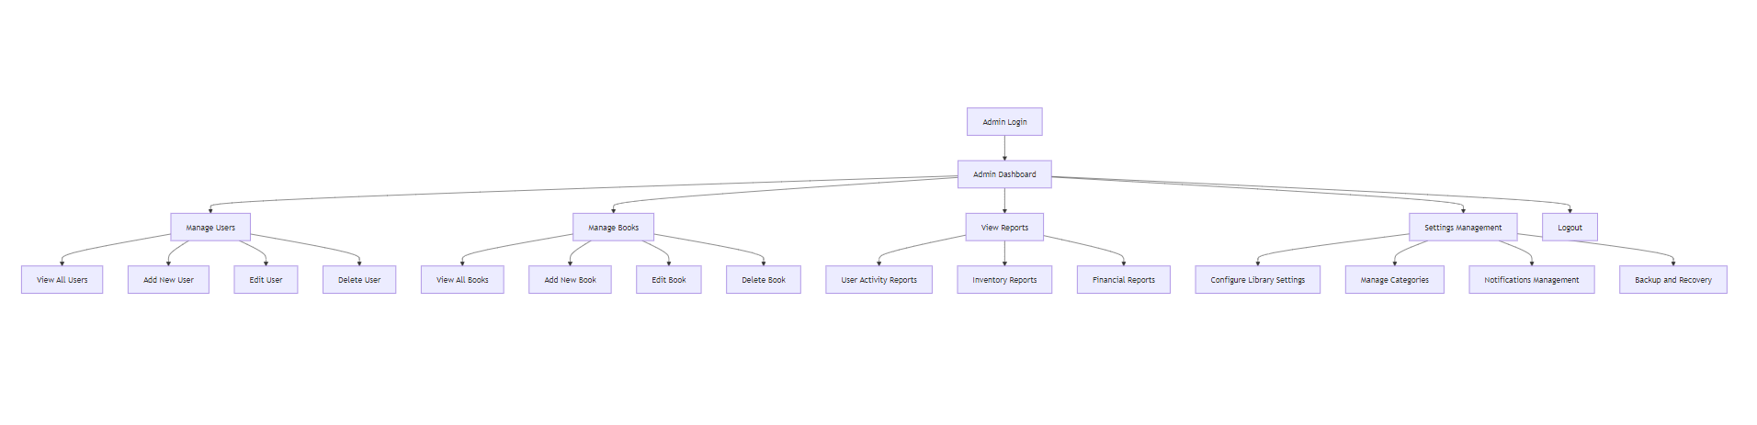  
**Link :** [**http://surl.li/whiloh**](http://surl.li/whiloh) **Please check this for flow understanding**

**Tech Stack**

### Summary of Tech Stack

* **Frontend**: React.js/Angular js
* **Backend**: Node.js (Express.js)
* **Database**: MongoDB
* **Authentication**: JWT, OAuth 2.0
* **Notifications**: Firebase Cloud Messaging
* **Payment Gateway**: Stripe/PayPal as per client needs
* **Deployment**: AWS
* **Version Control**: Git, GitHub

### Summary of the Complete Tech Stack

* **Frontend**:
  + Web: React.js + Tailwind CSS/Bootstrap
  + Admin: React.js/Angular + Material-UI
  + Mobile: React Native/Flutter
* **Backend**  
  + Node.js (Express.js)
  + MongoDB
* **Authentication**  
  + JWT
* **Notifications**  
  + Firebase Cloud Messaging
* **Payment Processing**  
  + Stripe/PayPal
* **Deployment**  
  + AWS

**Optional Features**

* **Mobile App**: For user-friendly access to library services.
* **Social Features**: Allow users to rate, review, and share books.

**3. Development Approach**

**Project Phases includes**

1. **Planning & Requirements Analysis**
   * Conduct detailed requirements gathering sessions.
   * Defining project scope, objectives, and deliverables.
2. **System Design**
   * Design system architecture and database schema.
   * Create user interface designs and user experience flows.
3. **Development**
   * Develop frontend and backend components.
   * Implement database schema and integrate with the application.
4. **Testing**
   * Perform unit, integration, user acceptance, and performance testing.  
     This testing we do before deploying the final product.
5. **Deployment**
   * Prepare production environment, perform final data migration, and launch the ERP system.
   * Provide immediate postlaunch support.
6. **Training & Documentation**
   * Conduct user training sessions.
   * Prepare and distribute user manuals and technical documentation.
7. **Maintenance & Support**
   * Offer ongoing technical support and system maintenance.
   * Monitor system performance and make necessary adjustments.

**Phases of project development includes**

**We follow a proper project management before developing any tech solution it helps us to understand client requirements as well this process helps client to understand the progress of project.  
  
  
  
  
  
  
  
  
  
  
Summary of the Phases**

* **Initiation**: Defining scope and goals.
* **Planning**: Develop detailed plans and specifications.
* **Design**: Create architecture and user interfaces. (UI/UX designing)
* **Development**: Build and integrate system components. ( Frontend development and Backend development)
* **Testing**: Validate functionality and performance.
* **Deployment**: Launch the application.
* **Training and Documentation**: Educate users and provide documentation.
* **Post-Deployment**: Support and improve the system based on feedback.

**Project Timeline**

| **Phase** | **Duration** | **Deliverables** |
| --- | --- | --- |
| Requirement Gathering | 1 weeks | Finalized project requirements document |
| Design Phase | 2 weeks | UI/UX design prototypes as per client needs |
| Development Phase | 3 -6weeks | Fully functional LMS frontend + backend |
| Testing Phase | 2 weeks | User acceptance testing and bug fixes |
| Deployment | 1 week | Live LMS implementation |
| Post-Deployment Support | Ongoing | Support and maintenance |

**Costing**

|  |  |
| --- | --- |
| ***Project Name*** | ***Costing*** |
| ***Library Management Software*** |  |